**Agent-based simulation of stakeholders relations:**

**An approach to sustainable port terminal management**

Lawrence E. Henesey*, Theo E. Notteboom**, and Paul Davidsson*

*Department of Software Engineering and Computer Science,

Blekinge Institute of Technology,

Karlshamn and Ronneby, Sweden

larry.henesey@bth.se; paul.davidsson@bth.se

* Department of Transport and Regional Economics, University of Antwerp Institute of Transport and Maritime Management Antwerp (ITMMA) – University of

Antwerp, Belgium

theo.notteboom@ua.ac.be

**ABSTRACT**

Port management is often faced with many vexing problems that are complex and difficult to define. Port policies are in some cases formed from idealized perspectives and market factors, with very little attention or understanding to stakeholder strategies. Stakeholder Relations Management (SRM) provides port management a means to consider stakeholders’ interests in issues related to sustainable port development and management (Notteboom and Winkelmans, 2002). Decision makers in port management have very few means of evaluating the stakeholder relationships and entities involved with port systems. This lack of information often results in ad hoc positions of port managers vis-à-vis stakeholders in the port community.

Simulation tools, in particular those using the Multi Agent Based Simulation (MABS) approach, may help to structure and better understand the relationships within complex organizations. The MABS approach has been applied to other areas of policymaking (Downing, 2000) and could be used to evaluate Stakeholder Relations Management (SRM) by modeling and simulating the different stakeholders in a port system. This paper aims to describe an approach (supported with MAS-CommonKADS) enabling decision makers to simulate various port policies and analyze the multitude of “what if” scenarios. The development of a state-of-the-art, MABS of SRM would be the basis for a decision-support system. The results of the simulation rather than guarantee an optimum policy solution, would offer decision makers the ability to view the structure of a port system and the functions that the stakeholders have under various “what if” analyses.

**KEYWORDS**: Port management, stakeholders, port policy simulation, multi-agent basedsimulation

1

**Agent-based simulation of stakeholders relations:**

**An approach to sustainable port terminal management**

1. **INTRODUCTION**

*“Increasingly, competition is not between companies but rather between whole networks, with the prize going to the company that has built the best network. The operating concept is simple: build a good network of relationships with key stakeholders, and profits will follow.” (Kotler, 2001)*

An IAPH report of the Combined Transport and Distribution Committee published in 1996 stated that a modern port is to be regarded as a function in a logistics system (IAPH, 1996). Ports find themselves embedded in ever changing logistics systems and networks. The globalising market place, with powerful and relatively footloose players, extensive business networks and complex logistics systems have a dramatic impact on the *raison d’être* of seaports. The logistics environment and the related risks and harms for the local community create a high degree of uncertainty and leaves port managers puzzled with the question how to respond effectively to market dynamics and to local community issues.

The port system is a complex system with many internal and external actors that are considered in this paper to be stakeholders in a port community, each with their own interests and objectives. However, according to a survey conducted by the European Sea Ports Organisation, only 17% of ports involved local communities and stakeholders in port development plans (Brooke, 2002). The use of networks as a metaphor has been used widely in scientific literature to describe the processes, activities, and relationships in ports and terminals (Gambardella et al., 1998, Frankel, 1987, Kia et al., 2000, and Notteboom and Winkelmans, 2002). The society or community view of a port or terminal may yield a richer detail of the inner workings of the structure and provide insight to the relationships between actors or stakeholders. In order to analyze the port community, an agent-based model will be used. The agent paradigm has been successful in modeling other societies or communities in varying fields of scientific research (see Bernard, 1999, Barton, 2000, and Downing, 2000). In building an agent based model to simulate stakeholder relationship management policies, a methodology known as the MAS-CommonKADS is employed in extracting and modeling knowledge on the port or terminal society.

The modeling and simulation of real systems, using terminals or ports, with the introduction of software agents has emerged as an interesting research area. Systems of this kind can be found in the transportation area with particular focus on traffic, logistics, supply-chain management, and physical distribution (Gambardella et al, 1998, Funk et al., 1998, Ljungberg and Lucas, 1992, Rebollo et al., 1999, Shinha Ray et al, 2003, Thurston and Hu, 2002, and Zhu and Bos, 1999). Most of these studies addressed pure operational issues such as the optimal use of available container handling equipment within a terminal. The use of modeling and simulation techniques to support policy decisions with respect to port functioning and port development, however, is a relatively little explored area of research.

The development of a MABS by using the MAS-CommonKADS provides a state-of-the-art technique in assisting port managers and decision makers to model and simulate port policies that may run to thousands of interactions amongst stakeholders. The use of MABS with SRM constitutes a *multi-disciplinary* approach that includes maritime economics,

2

distributed artificial intelligence, and stakeholder relations management in order to analyze the interests of various *stakeholders and their interplay and competition within ports.*

Port planning and the management of ports have often relied on various economic forecasting and econometric methods to guide port development policy. The introduction of stakeholder relation’s management offers policy makers, port operators, and decision makers a framework to analyze the various stakeholder relationships and how they are directly or indirectly involved in port activities and port development. We argue that relationships and behaviors of stakeholders can be successfully captured by the models that are found in the framework of MAS-CommonKADS (i.e., agent model, task model, and communication model). After the model of the stakeholders, represented by software agents, has been designed we can implement the MABS.

The outline of this paper is to introduce the subject of stakeholder relations management in port activities, which is the basis for conceptualizing a model to simulate the stakeholders in the port community. The MAS-CommonKADS methodology will be explained and how it is used in developing a multi-agent model of the container terminal community. To better grasp the essence of the MAS-CommonKADS methodology we deliberately focus on the container terminal community instead of on an entire port system with its multitude of stakeholders. A description of a prototype that is currently being built is followed by a discussion of future work and a conclusion.

1. **STAKEHOLDERS RELATION MANAGEMENT**

*2.1. The port community and the concept of ‘stakeholders’*

The success of a port is not only determined by infrastructure, superstructure and related output performances. It is increasingly being determined by the way the port manager succeeds in directing the interactions between different stakeholders towards a common objective as described by the mission statement. The concept of ‘stakeholders’ has become a key term in any port management strategy.

A stakeholder is any individual or group having interest or being affected by the port. A port both technologically and economically is in fact a node for contacts and contracts, whereby every stakeholder is driven by his/her own interests and priorities. Ports are associations where a multitude of individuals and interests (should) collaborate for the creation and distribution of wealth. Hence, the value creation process in ports is dependent upon the support of the different stakeholders groups. Each group of stakeholders however merits consideration for its own sake.

Following the broad view on stakeholders and taking the viewpoint of a landlord port authority, Notteboom & Winkelmans (2002) have identified four main stakeholder groups in a port community:

1. *The internal stakeholders*. They are part of the comprehensive port authorityorganization (port managers, employees, board members, unions and shareholders).
2. *The external stakeholders (economic/contractual )*. This group includes in situ and exsitu economic players. The in situ group consists of the different port companies and supporting industries that invest directly in the port area and who generate value-added and employment by doing so. The ex situ group would consist of industries located in the foreland and hinterland. A port also is a cluster of strongly intertwined economic activities with linkages to economic activities outside the port perimeter. Each

3

economic/contractual stakeholder in the port community can be brought into relation with one or more entities/functions within this economic cluster. Some of these companies are mainly involved in physical transport operations linked to cargo flows (e.g. terminal operators and stevedoring companies - including the carrier/terminal operator in case of dedicated terminals). Others solely offer logistical organization services (e.g. forwarding agencies, shipping agencies, etc.). Industrial companies in the port area (e.g. power plants, chemical companies, assembly plants,), supporting industries (e.g. ship repair, inspection services, etc.) and port labor pools also belong to the group of the first order economic stakeholders. Other economic stakeholder groups include port customers, trading companies and importers/exporters. They are less directly involved than the in situ economic groups, as they normally do not invest directly in the port. Nevertheless they follow the port evolution carefully, because port activity can influence their business results. Moreover, they exert strong demand-pull forces on port service suppliers and as such ‘dictate’ the market requirements to which the port community has to reply.

1. *Legislation and public policy stakeholders.* This group not only includes governmentdepartments responsible for transport and economic affairs on a local, regional, national and supranational level, but also environmental departments and spatial planning authorities on the various geographical decision levels.
2. *Community stakeholders.* Include community groups or civil society organizations, thegeneral public, the press, and other non-market players. They are concerned about the port’s evolution, i.e. mainly about its expansion programs, for reasons of well-being. They may experience actual or potential harms or benefits as a result of port action or inaction. It is possible that some community stakeholders may be unaware of their relationship to the port until a specific event - favorable or unfavorable - draws their attention. Figure 1 on the following page summarizes the various stakeholders of a port community identified by the authors.

Given the large number of stakeholders, port management is a complex matter. Port managers should acknowledge and whenever possible actively monitor the concerns of all legitimate stakeholders, i.e. they should take the interests of certain stakeholders appropriately into account in decision-making and operations. In taking particular decisions and actions, port managers should give primary consideration to the interests of those stakeholders who are most intimately and critically involved.

This balancing exercise is far from easy, given the latent danger of a struggle between port management objectives as a function of group interests. The underlying common interest of stakeholders of any port is the port’s survival, but it is too simplistic to assume that all parties accept that the main port development objective is ‘to provide port facilities and operating systems in the national interest at the lowest combined cost to the port and port users’ (UNCTAD, 1985:27). Conflicts of interests among different stakeholders may overshadow the community of interests. The objectives of environmental pressure groups are often conflicting with that of the port authority: for the one the less expansion the better, for the other almost continuous extension is required to cope with market opportunities in the foreland-hinterland continuum. The central government usually pursues socio-economic objectives through an active seaport policy. This policy is aimed at increasing the societal value-added of the national seaport system. The central government objectives may conflict with or at least diverge from objectives of the port authority. The objectives of the port industries and operators usually relate to traditional micro-economic goals such as a mix of shareholder value, maximization of profits, growth, increase in market share, productivity, etc.

4

***Figure 1*. *The Port Community Stakeholders according to the Authors***

(1)

(2)

(3)

(4)

|  |  |  |  |  |  |  |  |  |  |  |  |  |  |  |  |  |  |  |  |  |  |  |  |  |  |  |  |  |  |  |  |  |  |  |  |  |  |  |  |  |  |  |  |  |  |  |  |  |  |  |  |  |  |  |  |  |  |  |  |
| --- | --- | --- | --- | --- | --- | --- | --- | --- | --- | --- | --- | --- | --- | --- | --- | --- | --- | --- | --- | --- | --- | --- | --- | --- | --- | --- | --- | --- | --- | --- | --- | --- | --- | --- | --- | --- | --- | --- | --- | --- | --- | --- | --- | --- | --- | --- | --- | --- | --- | --- | --- | --- | --- | --- | --- | --- | --- | --- | --- |
| **INTERNAL STAKEHOLDERS** | | | | | | | | | | | | | | | | | | | | | | | | | | | | | | | | | | | | | | | | | | | | | | | | | | | | | | | | | | |  |
|  | | | | | | | | | | | | | | | | | | | | | | | | | | | | | | | | | | | | | | | | | | | | | | | | | | | | | | | | | | |  |
|  | *Groups inside port authority organization* | | | Managers | | | | | | | | | | | | Employees | | | | | | | | | Board members **SHAREHOLDERS** | | | | | | | | | | | | | | | | | | | | | | | | | | | | | | | | | |  |
|  | | | | | | | | | | | | | | | | | | | | | | | | | | | | | | | | | | | | | | | | | | | | | | | | | | | | | | | | | | |  |
|  | **EXTERNAL STAKEHOLDERS** | |  | ***SEA (IN/OUT)*** | | | | | | | | | | | |  |  |  |  |  |  |  |  |  |  |  | ***PORT*** | | | | | | | | | | | | | | | | | ***HINTERLAND (OUT/IN)*** | | | | | | | | | | | | | | |  |
| *Groups not part of port authority organization* | | | | | | | | | | | | | | | | | | | |  |  |  |  |  | |  |  |  |  |  |  | |  |  |  | |  | |  | | | | | | | | | | | | | | | | | | | |  |
|  | ***TRANSPORT OPERATOR GROUPS*** | | |  | | | | | | | | | | | | | | | | |  | | | | | | | | | | | | | | | | | |  | | | | | | | | | | | | | | | | | | | |  |
|  |  | | | | | | | | | | | | | | | |  |  | | | | | | | | | | | | | | | | | | | | | | | | | | | | | | | | | | | | | |  |
|  |  | | | | | | | | | | | | | | | | |  | | | | | | | | | | | | | | | | | | | |  |  | | | | | | | | | | | | | | | | |  |
|  |  |  | | | | | | | | | | | | | |  |  |  | | | | | | | | | | | | | | | | | | | |  |  | | |  | | | | | | | | | | | | |  |  |
|  | ***(including branch organizations)*** | | | ***Maritime transport*** | | | | | | | | | | | |  |  |  |  |  |  | ***Transhipment & storage*** | | | | | | | | | | | | | | | | | | |  |  |  |  |  |  |  |  |  |  |  |  | ***Rail*** | | | | | |  |
|  |  |  |  |  |  |  |  |  |  |  |  |  |  |  |  |  |  |  |  |  |  |  |
|  |  |  |  |  |  |  |  |  |  |  |  |  |  |  |  |  |  |  |  |  |  |  |
|  |  |  |  | Shipping line | | | | | | | | | | | |  |  |  |  |  |  |  | Stevedoring companies | | | | | | | | | | | | | | | | | |  |  |  |  |  |  | Railway companies | | | | | | | | | | | |  |
|  |  |  |  |  |  |  |  |  |  |  |  |  |  |
|  |  |  |  |  |  |  |  |  |  |
|  |  |  |  |  |  |  |  |  |  |  |  |  |  |  |  |  |  |  |  |  |  |  |  |  |  |  |  |  |  |  |  |  |  |  |  |  |  |  |  |  |  |  |  |  |  |  |  |  | ***Inland shipping*** | | | | | | | | | |  |
|  |  |  |  |  |  |  |  |  |  |  |  |  |  |  |  |  |  |  |  |  |  |  |  |  |  |  |  |  |  |  |  |  |  |  |  |  |  |  |  |  |  |  |  |  |  |
|  |  |  |  |  |  |  |  |  |  |  |  |  |  |  |  |  |  |  |  |  |  |  | ***Value-added activities*** | | | | | | | | | | | | | | | | | |  |  |  |  |  | Inland barge operators | | | | | | | | | | | | |  |
|  |  |  |  |  |  |  |  |  |  |  |  |  |  |  |  |  |  |  |  |  |  |  |  |  |  |  |  |  |
|  |  |  |  |  |  |  |  |  |  |  |  |  |  |  |  |  |  |  |  |  |  |  | Logistic service providers | | | | | | | | | | | | | | | | | |  |  |  |  |  |  |  |  | ***Road haulage*** | | | | | | | | | |  |
|  |  |  |  |  |  |  |  |  |  |  |  |  |  |  |  |  |  |  |  |  |  |  |  |  |  |
|  | ***TRANSPORT ORGANISATION GROUPS*** | | |  |  |  |  |  |  |  |  |  |  |  |  |  |  |  |  |  |  |  |  |  |  |  |  |  |  |  |  |  |  |  |  |  |  |  |  |  |  |  |  |  |  |  | Trucking companies | | | | | | | | | | | |  |
|  |  | | | | | | | | | | | | | | | | | | | | | | | | | | | | | | | | | | | | | | | | | | | | | | | | | | | | | | |  |
|  |  | | | | | | | | | | | | | | | | | | | | | | | | | | | | | | | | | | | | | | | | | | | | | | | | | | | | | | |  |
|  |  | | | | | | | | | | | | | | | | | | | | | | | | | | | | | | | | | | | | |  |  | | | | | | | | | | | | | | | |  |  |
| ***(including branch organizations)*** | | | | | |  | |  | |  | |  | |  | | |  | |  |  | | | | | | | | | | | | | | | | | | | | |  |  |  |  |  |  |  | |  |  | |  |  | |  |  |  | |  |
|  |  |  |  |  |  |  |  |  |  |  |  |  |  | Shipping agent | | | | | | | | | | |  |  |  |  |  |  |  |  |  | Freight forwarder | | | | | | | | | | | | | | | | | | | | | |  |  | |  |
|  |  |  |  |  |  |  |  |  |  |  |  |  |  |  |
|  |  |  |  |  |  |  |  |  |  |  |  |  |  |  |  |  |  |  |  |  |  |  |  |  |  |
|  | ***SUPPORTING SERVICES*** | | |  |  |  |  |  |  |  |  |  |  |  |  |  |  |  | Logistic service providers (3PL and 4PL) | | | | | | | | | | | | | | | | | | | | | | | | | | | | | | | | | | | | |  |  | |  |
|  |  |  |  |  |  |  |  |  |  |  |  |  |  |  |  |  |  |  |  |
|  |  |  |  |  |  |  |  | Towage companies | | | | | | | | | | | | | |  |  |  |  |  |  |  |  |  |  |  |  |  |  |  |  |  |  |  |  |  |  |  |  |  |  |  |  |  |  |  |  |  |  |  |
|  |  |  |  |  |  |  |  |  |  |  |  |  |  |  |  |  |  |  |  |  |  |  |  |  |  |  |  |  |  |  |  |  |  |  |  |  |  |  |  |  |  |  |
|  |  |  |  |  |  |  |  |  |  |  |  |  |  |  |  |  |  |  |  |  |  |  |  |  |  |  |  |  |  |  |  |  |  |  |  |  |  |  |  |  |  |  |
|  |  |  |  |  |  |  |  |  |  |  |  |  |  |  |  |  |  |  |  |  |  |  |  |  |  |  |  |  |  |  |  |  |  |  |  |
|  |  |  |  |  |  |  |  |  |  |  |  |  |  |  |  |  |  |  |  |  |  |  |  |  |  |  |  |  |  |  |  |  |  |  |  |  |  |  |  |  |  |  |
|  | ***(including branch organizations)*** | | |  |  |  |  |  |  |  |  | Pilotage services | | | | | | | | | | | | | Ship chandlers | | | | | | | | | | | | | | | | | | |  |  |  |  |  |  |  |  |  |  |  |  |  |  |  |  |
|  |  |  |  |  |  |  |  |  |  |  |  |  |  |  |  |  |
|  |  |  |  |  |  |  |  |  |  |  |  |  |  |  |  |  |  |  |  |  |  |  |  |
|  |  |  |  |  |  |  |  |  |  |  |  |  |  |  |  |  |  |  |  |  |  |  |  |  |  |  |  |  |  |  |  |  |  |  |  |  |  |  |  |  |
|  |  |  |  |  |  |  |  |  |  |  |  |  |  |  |  |  |  |  |  |  |  |  |  |  |  |  |  |  |  |  |  |  |  |  |  |  |  |  |  |  |
|  |  |  |  |  |  |  |  |  |  |  |  |  |  |  |  | Repair services (cf. shiprepair, container repair) | | | | | | | | | | | | | | | | | | | | | | | | | | | | | | | | | | | | | | | |  |  | |  |
|  |  |  |  |  |  |  |  |  |  |  |  |  |  |  |  |  |  |  |  |
|  |  |  |  |  |  |  |  |  |  |  |  |  |  |  |  |  |  |  |  |  |  |  | Waste reception facilities | | | | | | | | | | | | | | | | | | | | |  |  |  |  |  |  |  |  |  |  |  |  |  |  |  |  |
|  |  |  |  |  |  |  |  |  |  |  |  |  |  |  |  |  |  |  |  |  |  |  |  |  |  |  |  |  |  |  |  |  |  |  |  |  |  |  |
|  |  |  |  |  |  |  |  |  |  |  |  |  |  |  |  |  |  |  |  |  |  |  |  | Inspection services | | | | | | | | | | | | | | | | | | | |  |  |  |  |  |  |  |  |  |  |  |  |  |  |  |  |
|  |  |  |  |  |  |  |  |  |  |  |  |  |  |  |  |  |  |  |  |  |  |  |  |  |  |  |  |  |  |  |  |  |  |  |  |  |  |  |  |
|  |  |  |  |  |  |  |  |  |  |  |  |  |  |  |  |  |  |  |  |  |  |  |  |  |  |  |  |  |  | Banks, insurance companies, ... | | | | | | | | | | | | | | | | | | | | | | | | | |  |  | |  |
|  |  |  |  |  |  |  |  |  |  |  |  |  |  |  |  |  |  |  |  |  |  |  |  |  |  |  |  |  |  |  |  |  |  |
|  | ***INDUSTRY GROUPS*** | | |  |  |  |  |  |  |  |  |  |  |  |  |  |  |  |  |  |  |  |  |  |  |  |  |  |  |  |  | Legal firms (lawyers, ..) | | | | | | | | | | | | | | | | | | | | | | | |  |  | |  |
|  |  |  |  |  |  |  |  |  |  |  |  |  |  |  |  |  |  |  |  |  |  |  |  |  |  |  |  |  |  |  |  |  |
|  |  |  |  |  |  |  |  |  |  |  |  |  |  |  |  |  |  |  |  | | |  | | |  |  | | |  | | | |  | |  | |  | | |  |  |  |  |  |  | |  |  | |  |  | |  |  | |  |
|  | industries in foreland | | | | | | | | | | | |  |  |  |  |  |  | industrial companies in port | | | | | | | | | | | | | | | | | | | | | |  |  | industries in hinterland | | | | | | | | | | | | |  |
| ***(including branch organizations)*** | | | | | | | | | | | | | | | | | | | | | | | | | | | | | | | | | | | | | | | | | | | | | | | | | | | | | | | | | | |  |
|  | ***(PUBLIC) INFRASTRUCTURE COORDINATION,*** | | |  |  |  |  |  |  |  |  |  |  |  |  |  |  |  |  |  | port authorities of other seaports | | | | | | | | | | | | | | | | | | | | | | |  |  |  |  |  |  |  |  |  |  |  |  |  |  |  |  |
|  | ***FACILITATION & MANAGEMENT GROUPS*** | | |  |  |  |  |  |  |  |  |  |  |  |  |  |  |  |  |  |  |  |  |  |  |  |  |  |  |  |  |  |  |  | |  | |  | |  | | | terminal authorities | | | | | | | | | | | | | | | |  |
|  |  |  |  |  |  |  |  |  |  |  |  |  |  |  |  |  |  |  |  |  |  |  |  |  |  |  |  |  |  |  | Inland | | | | | | | | |  |
|  |  |  |  |  |  |  |  |  |  |  |  |  |  |  |  |  |  |  |  |  |  |  |  |  |  |  |  |  |  |  |  |  |  | Rail infrastructure management companies | | | | | | | | | | | | | | | | | | | | | | | | |  |
|  |  |  |  | Central, regional and local public authorities (cf. roads, (inland) waterways, ..) | | | | | | | | | | | | | | | | | | | | | | | | | | | | | | | | | | | | | | | | | | | | | | | | | | | | | | |  |
|  |  |  |  |  |  |  |  |  |  |  | Supranational public organisations (cf. EU, World Bank) | | | | | | | | | | | | | | | | | | | | | | | | | | | | | | | | | | | | | | | | | | | | | | | |  |
|  | ***LEGISLATION & PUBLIC POLICY GROUPS*** | | |  |  |  |  |  |  |  |  |  |  |  |  |  |  |  |  |  |  |  |  | central and regional governments (including port commissions) | | | | | | | | | | | | | | | | | | | | | | | | | | | | | | | | | | |  |
|  |  |  |  |  |  |  |  |  |  |  |  |  |  |  |  |  |  |  |  |  |  |  |  |  | European Union | | | | | | | | | | | | | | | | | | |  |  |  |  |  |  |  |  |  |  |  |  |  |  |  |  |
|  |  |  |  |  |  |  |  |  |  |  |  |  |  |  |  |  |  |  |  | Trade negotiations groups (cf. WTO) | | | | | | | | | | | | | | | | | | | | | | | |  |  |  |  |  |  |  |  |  |  |  |  |  |  |  |  |
|  | ***COMMUNITY GROUPS*** | | |  |  |  |  |  |  |  |  |  |  |  |  |  |  |  |  |  |  |  |  |  |  |  |  |  |  |  |  | Local inhabitants groups | | | | | | | | | | | | | | | | | | | | | | | | | | |  |
|  |  |  |  |  |  |  |  |  |  |  |  |  |  |  |  |  |  |  |  |  |  |  |  |  |  |  |  |  |  |  |  | Consumers/ tax payers | | | | | | | | | | | | | | | | | | | | | | | | | | |  |

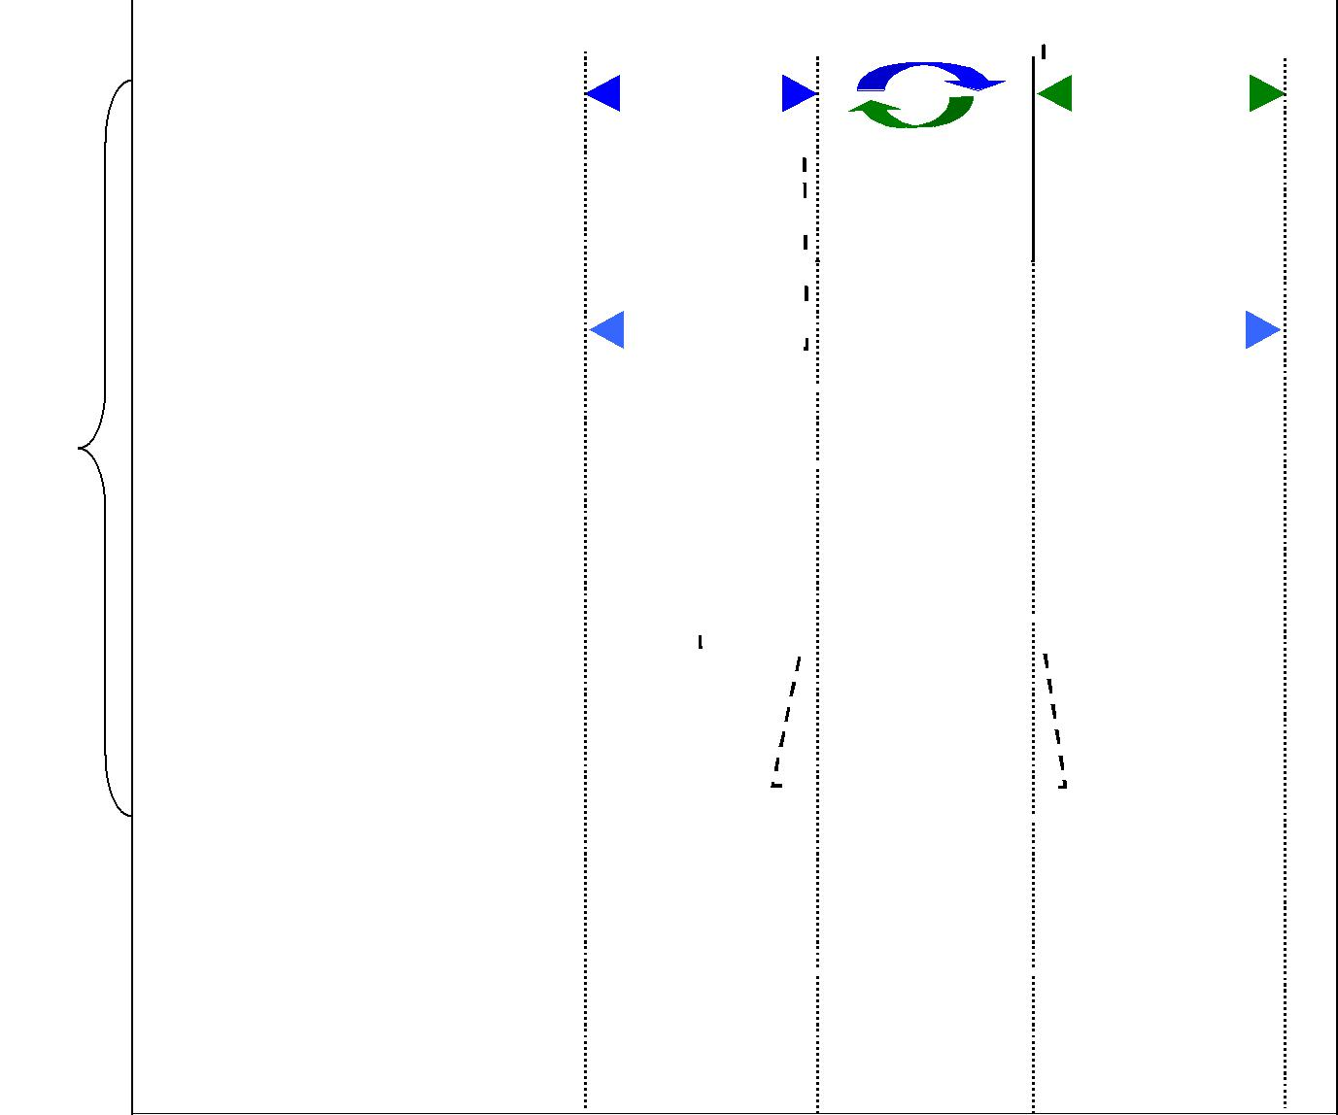

Environmentalist groups of a local, regional or global scale

The press

= the 'port' or 'port community' as perceived by many external entities



*2.2. Structuring relationships between and within stakeholder groups*

Two forms of interaction characterize the inter-organizational relationships among stakeholders: *physical* (i.e. related to the physical transfer of cargo) and *incorporeal* (Martin

* Thomas, 2001). The latter type of interactions consists of contractual, supervisory or information based exchanges. The interactions between port authorities and the first order port players are mainly of an incorporeal kind. For instance, port companies involved in physical operations are linked to the port authority via concession agreements (esp. in case of landlord port authority).

There are several concerns that shape the relationships between and within stakeholder groups (Notteboom and Winkelmans 2002):

* distributional concerns, i.e. issues related to the distribution of costs and benefits among stakeholders, the trade-offs (e.g. between economic, ecological and the social value of ports) and the creation of win-win situations
* efficiency concerns, i.e. maximum output generation with a minimum of inputs

5

* behavioral concerns, e.g. related to cheating behavior, opportunism and bounded rationality. For instance, local pressure groups often defend their local interests in such a fierce way that the individual well being of a few people is becoming an even bigger driving force than the well being of the greater community.

These aspects do not only play a role in formal contracting among stakeholders, but also in less formal situations of stakeholder interaction.

Port managers need a better understanding of the relationships between and within different stakeholders groups as well as of the divergence/convergence of objectives and concerns among stakeholders. In most port organizations such an exercise is not done in an explicit way. Port managers typically take account of the behavior and perceived objectives of the different stakeholders, but they seldom have a good overall picture of the underlying dynamics that shape stakeholders relations. As a result, stakeholder relations management in ports typically is of an *ad hoc* nature and does not rely on any kind of framework that could help to assess possible action/reaction patterns in stakeholder relations.

*2.3. Objective struggle and stakeholders relations in the container terminal community*

The container terminal (CT) community consists of many market players and non-market players. The CT community is in fact a subset of the larger port community. The actors that are located in the CT community are found in Figure 2. The *physical* inter-organizational relationships between actors in the CT community are mainly of an operational nature i.e. related to the cargo handling itself. The *incorporeal* inter-organizational relationships between actors in the CT community are between organizations such as customs and port authority.

***Figure 2. The container terminal community and its stakeholders***

Central or regional

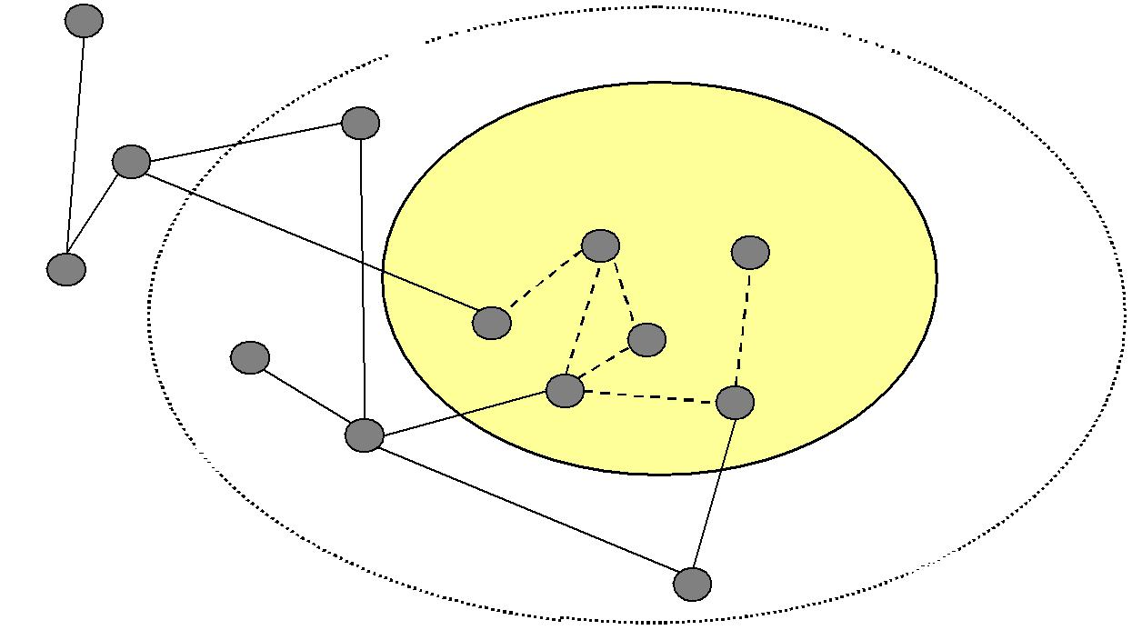

government

 **Economic/commercial port community**

|  |  |  |  |
| --- | --- | --- | --- |
| Customs |  | **Container terminal community** |  |
|  | Legal firms |  |
|  |  |  |
|  |  | **CT operator** |  |
|  |  | **Inland Transport** |  |
|  |  | **operator** |  |
|  |  | **Port Authority** |  |
| Public |  | **Ship Agent** |  |
|  |  |  |
| authorities |  | Stevedore |  |
|  |  |  |
|  | Banks | **Shipping line/ alliance** |  |
|  |  |  |

Shippers

Freight Forwarders

The relationships between and within stakeholder groups in the CT community are shaped by mutual concerns and converging/diverging objectives. Congestion and increasing cargo dwell times is a common scene in many of the world’s ports. Government authorities such

6

as customs and health may delay containers from reaching their destinations due to inspections. Shipping lines are unconcerned if there is a poor terminal productivity, as long as their vessel sails on time. Terminal operators are trying to reduce or stabilize the cost per TON/TEU (twenty-foot equivalent unit: container) handled and thus maximize profit. Ports and terminal operators are also cognizant of the coming changes and perhaps threats if they do not keep up with the pace of change. Ports such as Antwerp, Rotterdam, and Hamburg are expanding their terminals or creating new terminals to accommodate the projected rise in number of containers. The CT investment in Europe (1999-2001) was approximately 208 million Euros (Wiegmans et al., 2002). It is evident ports are seeking better ways in improving their productivity and offering logistical solutions to shippers of cargo. No longer are ports handling just cargo, but more and more they are becoming *“information handlers*” (Henesey, 2002).

Efficiency concerns are vital here. However, behavioral aspects can have an impact on the efficiency objective. For instance, human behavior might impede terminal operators from achieving an optimal terminal system configuration. Incorrect or incomplete information results in bounded rationality in terminal operators’ terminal configuration, leading to sub-optimal decisions. Secondly, opportunistic behavior of economic actors or informal commitments to individuals or companies might lead to non-cost minimizing decisions. Thirdly, terminal operators might stick to a specific configuration as they assume that the mental efforts (inertia) and transactions costs linked to changes in the terminal configuration will not outweigh the extra costs of the current non-optimal solution.

Due to increases in speed, volume, and behavioral influences, the operations of a CT requires a better regulating systems approach. One area where terminal operators are experiencing problems is reducing the unproductive and expensive container moves in a terminal. Software technologies such as agents may be able to assist terminals in increasing capacity and performance without spending large investments on terminal expansion and equipment. The “software” rather than the “hardware” of port development will be the determining factor in future trends in port competition vis-à-vis terminal management (Winkelmans and Van de Voorde, in Huybrecht et al (eds.) 2002).

1. **MULTI-AGENT BASED SIMULATION**

In Distributed Artificial Intelligence lies a new paradigm, a converging technology called agent or Multi -Agent Systems (MAS). Agents can be seen as a system capable of interacting independently and effectively within its environment in order to accomplish given or self-generating task(s) (Davidsson 1996). The main characteristics of agents are autonomy, pro-activity, coordination, and communication. This approach facilitates in designing a distributed model of the CT, where agents carry out the processes and tasks. By having more than one agent, the model becomes a MAS, which leads to more complex issues, such as how are the agents to communicate or work together in order to fulfill task(s) or goal(s). Development in this area has led to a number of agent-oriented technologies such as multi-agent based simulation (MABS).

MABS differs from other kinds of computer- based simulation in that (some of) the simulated entities are modeled and implemented in terms of agents. As MABS, and other micro simulation techniques, explicitly attempts to model specific behaviors of specific individuals, it may be contrasted to macro simulation techniques that are typically based on mathematical models where the characteristics of a population are averaged together and the model attempts to simulate changes in these averaged characteristics for the whole

7

population. Thus, in macro simulations, the set of individuals is viewed as a structure that can be characterized by a number of variables, whereas in micro simulations the structure is viewed as emergent from the interactions between the individuals. Parunak et al. (1998) recently compared these approaches and pointed out their relative strengths and weaknesses. They concluded, “…agent-based modeling is most appropriate for domains characterized by a high degree of localization and distribution and dominated by discrete decision. Equation-based modeling is most naturally applied to systems that can be modeled centrally, and in which the dynamics are dominated by physical laws rather than information processing.”

If we compare MABS to traditional simulation approaches, e.g., Discrete Event Simulation (DES), we find that it has several advantages. It supports structure preserving modeling and implementation of the simulated reality. That is, there is a close match between the entities of the reality, the entities of the model, and the entities of the simulation software. This simplifies both the design and the implementation of the software, and typically results in well-structured software. In addition, MABS has the following important advantages compared to more traditional DES techniques (Davidsson 2000):

* It supports modeling and implementation of pro-active behavior, which is important when simulating human decision-makers that are able to take initiatives and act without external stimuli.
* Since each agent typically is implemented as a separate process and is able to communicate with any other agent using a common language, it is possible to add or remove agents during a simulation without interruption. And, as a consequence of this and the structure preserving mapping between the simulation software and the reality, it is even possible to swap an agent for the corresponding simulated entity, e.g., a real person during a simulation. This enables extremely dynamical simulation scenarios.
* It is possible to program (or at least specify) the simulation model and software on a very high level, e.g., in terms of beliefs, intentions, etc., making it easier for non-programmers to understand and even participate in the software development process.
* It supports distributed computation in a very natural way. Since each agent is typically implemented as a separate piece of software corresponding to a computational process (or a thread), it is straightforward to let different agents run on different machines. This allows for better performance and scalability.

From this we conclude, and have been argued by Downing et al. (2000) and others, that the MABS approach seems very promising for simulating stakeholder interactions such as in a seaport environment. In addition, a number of researchers have argued that the use of MAS as a metaphor in container and/or intermodal terminals is valid and supported by previous research (Gambardella, et al., 1998, Zhu and Bos, 1999, Funk et al., 1998, Henesey et al., 2002, Thurston and Hu, 2002, and Sinha-Ray et al., 2003).

We will here model the CT community using MABS, where a software agent represents a physical stakeholder. In a MABS different agents may have different roles and also individual goals. The use of agents representing the various organizations or actors may provide alternative solutions in order to optimize the resources in the total terminal operations process.

The execution of the MABS may result in behavior or patterns that are interesting for analysis. This resulting or emerging behavior of the various agents modeled at a micro level and than simulated on a macro level would facilitate in better understanding of the complex interactions of the modeled agents. This understanding undeniably would contribute to a more structured approach on stakeholder relations management. There do exist other micro-

8

modeling simulating strategies, however these strategies only model the entity at the micro level only, where as MABS allows the entities to interact and allow researchers to observe the behavior under complexity.

1. **MAS-COMMONKADS**

Many methodologies exist for developing MAS (see Grüer et al., (2002) for short survey and description on formal frameworks for MAS analysis and design). Methodologies usually consist of models and rules that help to formalize the understanding of the system being analyzed. By using a formal approach to modeling, it allows the implementation of a system to be built more robustly.

According to Wooldridge (2002), there are basically two types of MAS methodologies, which can be use for analyzing and designing an agent-based system:

* methodologies that are rooted in object-oriented development; and
* methodologies adapted from knowledge engineering or other techniques.

The MAS-CommonKADS is a methodology adapted from Knowledge Engineering that we have used in designing the software agents by eliciting information from the physical (human) stakeholders. We considered using the MAS-CommonKADS because:

* applications of MAS-CommonKADS have been successful in various related areas such as the flight reservations systems (Arenas and Barrera-Sanabria 2002) and the steel roll-mill (Iglesias et al. 1998); and
* previous experience in using CommonKADS to model port knowledge in Karlshamn, Sweden, assisted in understanding the port operations.

Alternative methodologies were considered, such as the Gaia design model developed by Wooldridge (2002). However the Gaia model is primarily an analysis method.

The MAS-CommonKADS is an extension of CommonKADS, which is a formal methodology for the development of knowledge -based systems (KBS) and designing software to build such systems (Schrieber et al. (2001). The extension of the CommonKADS with Multi Agent Systems has largely been the result of work done by Iglesias et al. (1998) and Arenas and Barrera-Sanabria, (2002). According to Iglesias et al.

(1998) the potential benefits for using MAS-CommonKADS are:

* The decisions on the selection of a multi-agent platform and architecture for each agent are documented.
* The design model collects the information of the previously developed models and details how these requirements can be achieved.
* The design model for MAS determines the common resources and needs of the agents and designs a common infrastructure managed by network agents. This facilitates in the design.

The MAS-CommonKADS, similar to the CommonKADS methodology, incorporates seven individual models that assist in eliciting tacit knowledge. Each model consists of entities to be modeled and relationships between the entities (Iglesias et al., 1998). The relationships between the seven models are described in Figure 3. The seven models:

* *Agent model* describes the characteristics of each agent.
* *Task model* decomposes and describes the tasks required for an agent. Also, determineswhat the goal(s) are.

9

* *Expertise model* (Knowledge) describes the knowledge needed by the agents to achievetheir goals
* *Organization model* describes the structural relationships between agents (softwareagents and/or human agents);
* *Coordination mode* is a descriptive model of the interactions and protocols betweenagents and describes the dynamic relationships between software agents
* *Communication model* focuses on modeling the dialogue between agents and describesthe dynamic relationships between human agents and their respective personal assistant software agents
* *Design model* refines the previous models and determines the most suitable agentarchitecture for each agent, and the requirements of the agent network.

***Figure 3. The MAS-CommonKADS model.***

|  |  |  |  |  |  |  |  |
| --- | --- | --- | --- | --- | --- | --- | --- |
| *Context:* | **Organisation** |  | **Task Model** |  | **Agent Model** | |  |
| **Model** |  |  |  |  |  |  |
|  |  |  |  |  |  |  |
|  |  |  |  |  |  |  |  |
|  |  |  |  |  |  |  |  |
| *Concept:* | **Expertise** |  | **Communication** |  | **Coordination** |  |  |
|  | **Model** |  | **Model** |  | **Model** |  |  |
|  |  |  |  |  |  |  |  |
| *Artefact:* |  |  | **Design Model** |  |  |  |  |
|  |  |  |  |  |  |  |
|  |  |  |  |  |  |  |  |

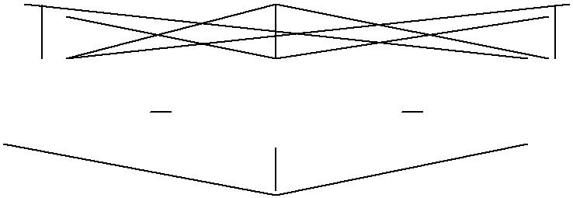

The overall MAS-CommonKADS methodology for multi-agent systems development, according to Iglesias et al. (1998) follows these phases:

* *Conceptualization.* Elicitation task to obtain a first description of the problem anddetermination of use cases which can help to understand informal requirements Potts et al. (1994 cited Iglesias 1998, p. 2) and to test the system.
* *Analysis.* Determination of the requirements of the system starting from the problemstatement. During this phase the following models are developed: *Organization Model,* *Task Model, Agent Model, Communication Model, Coordination Model and Expertise Model.*
* *Design.* Here is determined how the requirements of the analysis phase can be achievedby the developing of the *Design Model*. It is determined the architecture of both the global multi-agent network and each agent.
* *Coding* and *testing* of each agent
* *Integration.* The overall system is tested.
* *Operation* and *maintenance*.

In what follows, particular attention is focused on the *Agent Model, Task Model, and* *Organization Model* in order to successfully simulate the stakeholders’ relations contextualenvironment.

10

1. **TERMINAL COMMUNITY MODEL**

We have completed the conceptualization phase and are currently in the analysis phase. The model of the container terminal community is populated by many agents (stakeholders) that posses individual goals (set of functions that are specified). The trade-offs that may occur in reaching a desired state can be reviewed through simulation experiments. Through using the MAS-CommonKADS, the set or ranges of parameters can be assessed while the simulation provides a means to evaluate many different alternatives, i.e. supporting stakeholder relations management.

5.1 *Conceptualization*

The knowledge of the port domain was obtained via interviews with various port managers in Europe, North America and in South Africa. The experience of one of the authors in working in terminal operations with Evergreen has provided additional help in understanding the port system. Through the information and data collected, scenarios were developed and stakeholder roles were identified. From the scenarios, the context of the port system is developed and is eventually refined via the use of the models in MAS-CommonKADS.

5.2 *Analysis*

The analysis phase assists in the development of requirements specification. The work sheets and templates of the MAS-CommonKADS methodology assisted in the mapping of the physical stakeholders to agents for the port simulator. Since we will develop a simulator (where stakeholders/agents exist apriori), this task is more straightforward than if, for instance, a control system was to be developed. That is, the task is to *identify* them rather than *inventing* them. The *Organization Model, Agent Model, Task Model* each will be individually discussed below, whereas the *Coordination Model, Communication Model and* *Expert Model* are only briefly discussed.

*5.2.1 Organization Model*

The *organization model* provides through five worksheets, a structured view of the *static* relationships and ties between the agents (stakeholders) and their environment in a systematic approach. The *organization model* assists in analyzing the organization in locating bottlenecks, problems, and potential solutions. The model is viewed as an important first step in the developing the context of the CT environment. Most of the hierarchical processes found in a CT often differ from other CTs, e.g. the port of Karlshamn has a flat hierarchy separated between administration and operations. The feasibility of structuring the organization is ascertained by looking at organization from a knowledge orientation point of view. The model provides information on the organizations work processes and assists in identifying the impact of implementing a MAS. The information or data obtained in the *organization model* contributes to the building of the *task model* and *agent model.* In addition, the organization model elicits organizational information thatincludes: culture, mission, strategy, problems, opportunities, and knowledge assets. An overview of the organization model is described in Figure 6.

11

***Figure 6 Overview of Organization Model Worksheets from Schreiber et al. (2001).***

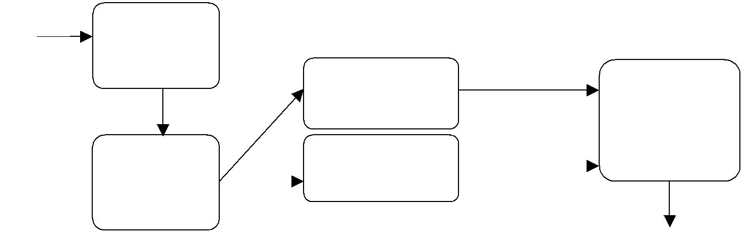

**Start** **OM-1**:

|  |  |  |  |  |
| --- | --- | --- | --- | --- |
| problems, |  |  |  |  |
| solutions, |  |  |  |  |
| context | **OM- 3:** |  | **OM- 5:** |  |
|  | Process breakdown | integrate | Judge feasibility |  |
|  | refine | (decision |  |
|  |  |  |
|  |  |  | document) |  |

|  |  |  |  |  |  |
| --- | --- | --- | --- | --- | --- |
| **OM- 2:** |  | **OM- 4:** |  |  |  |
| description of |  | Knowledge assets |  |  |  |
|  | integrate | |  |
| organization |  |  |  |
|  |  |  |  |  |
| focus area | refine |  | If feasible | |  |

*5.2.2 Agent Model*

The A*gent Model* worksheets assist in collecting particular characteristics of the agents, e.g. the Yard planner in a CT would not control the arrival of trucks to the gate or allocation of gantry cranes to a vessel. The example of the agent model for the ship planner is described in Figure 4. From the list of stakeholders found in Figure 1, we were able to identify the following stakeholders to be considered for the CT model:

* *Ship planner’s* main task is to conduct calculation that lead to producing a load lists. Theload list assists in correctly and efficiently loading and unloading a ship according to various parameters and constraints. The planner may request additional equipment.
* *Port Captain* is concerned with optimal allocation of fixed capital, such as the berth andcranes to the customer (ships and cargo).
* *Yard planner* manages the physical stacks of cranes according to various policies.
* *Stevedore* is focused on the physical handling and providing the service as demanded bythe ship agent.
* *Port Authority* maximize throughput, quality of service, and return on capital investedwhile seeking to minimize vessel time in port.
* *Ship Agent* seeks to minimize port user costs on behalf of the ship owner.
* *Shipping Line or Alliance* is interested at maximizing net profits, operating at least cost
* *Inland Transport operator* is concerned with providing quality service, low costs,maximizing return and profits while minimizing costs.

|  |  |  |
| --- | --- | --- |
|  |  | ***Figure 4. Agent Model of Ship Planner*** |
|  |  | |
| **Agent Model** | **Agent Worksheet AM-1** | |
|  |  |  |
| *Name* | 1. | Ship planner |
| *Organization* | 2. | Centralized-command hierarchical systems |
| *Involved in* | 3. | Producing work schemes, planning of loading and discharge of vessels. Involved with |
|  |  | information analysis and calculations |
| Communicates | 4. | Stevedore, Ship Agent, Ship Line, and with Yard Planner |
| with |  |  |
| Knowledge | 5. | Algorithms to sort and load |
| Other | 6. | Print, distribute, and retrieve information |
| competencies |  |  |
| Responsibilities | 7. | Responsibilities: produce an “error free” load list that minimizes the handling required by the |
| and Constraints |  | terminal. |
|  | 8. | Constraints: quality of information entered, Amount of information entered, up-to-date rules. |
|  |  | 12 |

*5.2.3 Task Model*

The *task model* assists in locating which objects are to be utilized or handled in the CT for executing a specific task. The degree and manner that the tasks are executed and the effects that a particular task may have on another task or tasks are identified and listed in Figure 5. As mentioned by Iglesias et al (1998), the advantages of documenting the tasks and activities of the organization assist in the management of changes in the organization. The model assists in analyzing the resources, competencies, performance demands and other conditions in the carrying out the main business function, i.e. handling cargo or containers.

***Figure5. Task Model for Loading a Vessel***

|  |  |  |
| --- | --- | --- |
| **Task Model** | **Task Analysis Worksheet TM-1** | |
| Task | Cf OM-3 | Loading |
|  |  |  |
| *Organisation* | Cf OM-2 | Vessel Operations in a CT |
|  |  |  |
| *Goal and Value* |  | To load vessel with less moves as possible. Using |
|  |  | “Quality” (i.e. fast, complete, and correct), information. |
|  |  | **Codify experience** Value is faster turn-around time for |
|  |  | vessel and less costs for loading. |
| *Dependency and Flow* | 1.preceding tasks | Input: **tasks 1,2** (receive information of container) **task 4** |
|  | 2. follow-up tasks | (place it at its best position at vessel. |
|  |  | Output: Print or send a schematic diagram *(Manifest*) of |
|  |  | what and where each container is to be loaded. |
| *Objects handled* | Input objects | Information (B/L or TIR) |
|  | Output objects | Scheme-Manifest. Vessel “worked” |
|  | Internal objects | Reports, load list, customs docs. |
| *Timing and Control* | Frequency, duration | Frequency: 24 hours 7 days a week. |
|  | Control | Duration: 1 hour |
|  | Constraints and Conditions | Constraints: Security and Safety. |
|  |  | Tasks 1,2, 3, are preconditions. Conditions are time, |
|  |  | moves, rules for stowage, |
|  |  | Post conditions are a Manifest that shows a well planned |
|  |  | and loaded vessel Less moves and having a faster turn |
|  |  | around is the objective |
| *Agents* | OM2: People, System | Computer to help plan, (ship planners) print out plan for |
|  | Resources; | distribution to the stevedores (varies between 5 to 7 |
|  | Om-3: Performed by | members). Personal (ship planner and yard planner) key |
|  |  | in and monitor the plan. |
| *Knowledge and* | Cf.OM-4 | Vessels ops (ship planner) the loading |
| *Competence* |  | Knowledge of computer, constraints, scheme of vessel, |
|  |  | what are the rules for each container? Ports of |
|  |  | destination? Weights? Hazardous Y/N, proper |
|  |  | documentation |
|  |  |  |
| *Resources* | Detailing of OM-2 | Computer systems, staff equipment (cranes & container |
|  |  | fork lift) |
|  |  |  |
| *Quality and* | Measures | Each unit has it's own set goals. |
| *Performance* |  |  |

*5.2.4 Other Models*

The *communication model* includes interactions between stakeholders that may be involved in a task, e.g. the *Port Captain* agent and other agents (ship planner, stevedore, ship agent, etc.) involved in scheduling operations for a vessel in a CT. The communication transactions between the stakeholders are labeled and modeled. The *coordination model* uses templates similar to those of the *communication model*, but taking into consideration human factors such as facilities for understanding the recommendations given by the system. The templates assist in understanding the coordination process within the terminal, e.g. straddle carriers may be bounded to a single gantry crane and can not feed containers to another gantry crane working on the same ship. The *expertise model* is split into the development of the application knowledge and the definition of the problem solving method (Schreiber et al. 2001). In order to develop the application knowledge, we determine the domain knowledge, which defines the ontology and models of the domain; the task

13

knowledge, which specifies the knowledge needed by a task to reach its goals; and the inference knowledge, which represents the inference steps needed to solve a task.

1. **SIMULATOR SOFTWARE**

The CT simulator is composed of two systems, the *stakeholder agents* and *physical* *environment.* The stakeholder *agents* system is where decisions are made and informationis generated, i.e. ship planning, berth assignments, and ship line schedules. From the interactions between the *stakeholder agents*, appropriate decisions are made and sent to the CT simulator located in the *physical environment. The physical environment* generates information from the simulations that is sent to the *stakeholder agents* The communication between the two systems is built on Java programming language using the RMI facility and facilitates what the two systems require, namely sending information (objects) to each other. A diagram of the prototype of the CT system is shown in Figure 7 and is being developed partially from a case study of a terminal in Sweden.

***Figure 7. The architecture of the prototype simulator***

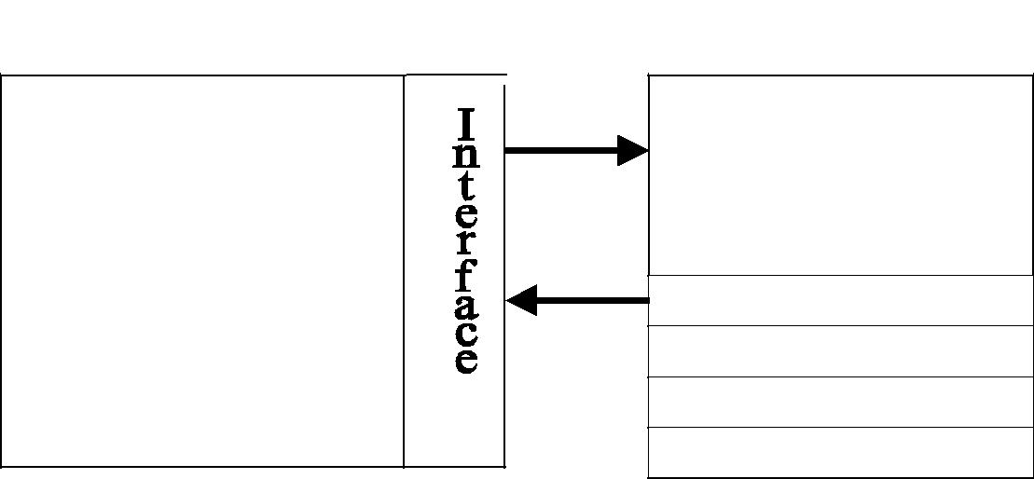

*Physical Environment* *Stakeholder Agents*

**Container Terminal**

**Simulator**

CT Management System

* Ship planner
* Port Captain
* Yard planner
* Stevedore

Port Authority

Ship Agent

Shipping Line/Alliance

Inland Transport operator

The environment of the model is not fully designed from the worksheets. The berthing and loading/unloading operations have been modeled and simulated. The modeling of the stakeholder agents has been designed but not fully implemented; only the ship planner and port captain are functional.

1. **CONCLUSION AND FUTURE WORK**

So far, the methodology has assisted in providing the tools to help design the CT system simulator. The information collected from the various worksheets in MAS-CommonKADS is quite formal and often repetitive. We feel that with more experience in using the methodology, some of the worksheets may be omitted or combined with other worksheets. The MAS-CommonKADS worksheets place much emphasis on the structuring of the information and may slow the work process on the building of the CT simulator. The container terminal domain provides an interesting area to model stakeholders with agents. The application of the MAS-CommonKADS methodology provides in general, a robust method in designing the software to simulate from different models. We argue that the methodology provides the backbone on which state-of-the-art simulation software can be developed in order to conduct agent-based simulation on stakeholder relations in a container terminal. The software process uses both the risk-driven approach with the component-

14

based approach. After every cycle in MAS-CommonKADS, the models are evaluated and analyzed before continuing forward in order to reduce any perceived risks in developing the tool (agent-based simulator).

In general, the MAS-CommonKADS provided a good, clear methodology for those that are not involved in software development to understand and participate in the design processes. The methodology assists practitioners from other fields of science, i.e. economics, in building a MABS. We have presented the initial steps in developing a MABS of SRM (Stakeholder Relations Management). The goal is to develop a MABS that can be used for evaluating policies for port terminal systems from stakeholders’ perspectives. The plan is to conduct a more thorough analysis of a major container terminal.

The concepts underlying the CT community model can also be employed to analyze stakeholder relations on a broader scale, i.e. the port community as a whole. As such the MAS-CommonKADS provides a powerful tool to structure stakeholder relations and as such is helpful when developing a more structured stakeholder relations management.

1. **ACKNOWLEDGEMENTS**

We wish to thank Dr. Jan Persson and MSc. Anatoly Chervyakov at Blekinge Institute of Technology for providing assistance and suggestions.

1. **LIST OF REFERENCES**

Arenas, A. E., Barrera-Sanabria, G. (2002) Applying the MAS-CommonKADS Methodology to the Flights Reservation Problem: Integrating Coordination and Expertise, *Proceedings of the Fifth Joint Conference on Knowledge-Based Software* *Engineering (JCKBSE 2002)*, Maribor, Slovenia.

Barton, D.C. (2000) Analysis of Complexity in Infrastructure Systems Using Agent Based Microsimulation, *Proceedings of the RAND workshop, Complex Systems and Policy* *Analysis: New Tools for a New Millennium*. Arlington, Virginia, US.

Bernard, R.N., (1999) *Using Adaptive Agent-Based Simulation Models to Assist Planners in* *Policy Development: The Case of Rent Control*. Santa Fe Institute.

Brooke, J. (2002) Stakeholder Participation in Port Development Decision Making: How?, Where? and When? *Proceedings of the 30th* *International Navigation Congress* *(PIANC 2002),* Sydney, Australia, 1990-1991.

Davidsson, P. *Autonomous Agents and the Concept of Concept*s. PhD. Thesis, Lund University, Lund, Sweden, 1996.

Davidsson, P. (2000) Multi Agent Based Simulation: Beyond social simulation, *Multi* *Agent Based Simulation*, Springer-Verlag LNCS series, Vol. 1979.

Downing, T.E., Scott, M., Pahl-Wostl, C., (2000) Understanding Climate Policy Using Participatory Agent-Based Social Simulation. *Multi-Agent-Based Simulation*,

S. Moss, and P. Davidsson, (eds.). LNAI Vol. 1979. 2000, Berlin: Springer-Verlag, 198-213.

Frankel, E. G. (1987) *Port Planning and Development*. John Wiley & Sons. New York, US. Funk, P., Vierke, G., Bürckert, H-J. (1998) A Multi-Agent Perspective on Intermodal

Transport Chains. *Deutsches Forschungszentrum für Künstliche Intelligenz, Report* *DFKI-TM-98-06*. Saarbrüken, Germany, 1-14.

Gambardella, L.M., Rizzoli, A.E., Zaffalon, M. (1998) Simulation and Planning of an

15

Intermodal Container Terminal.” *Special Issue of Simulation Journal in Harbour* *and Maritime Simulation* **21**(2), 107-116.

Grüer, P., Hilaire, V., Koukam, A., Cetnarowicz, K. (2002). A formal framework for multi-agent systems analysis and design, *Expert Systems with Applications* **23**(4), 349-355.

Henesey, L. (2002) Enhancing Terminal productivity through Artificial intelligence: Multi-Agent Approach, Proceedings of the 26th Terminal Operators Conference (TOC-2002), Antwerpen, Belgium.

Henesey, L., Wernstedt, F., and Davidsson, P. (2003). Market-Driven Control in Container

Terminal Management, *Proceedings of the 2nd International Conference on* *Computer Applications and Information Technology in the Maritime Industries (COMPIT´03),* Hamburg, Germany.

Huybrechts, M., Meersman, H., Van De Voorde, E., Van Hooydonk, E., Verbeke, A., Winkelmans, W. (2002) *Port competitiveness: an economic and legal analysis of the* *factors determining the competitiveness of seaports*, Editions De Boeck,Antwerp.

IAPH (International Association of Port and Harbors), URL: http://www.iaphworldports.org Iglesias, C., Garijo, M., Gonzalez, J. C., Velasco, J R. (1998) Analysis and design of

multiagent systems using MAS-CommonKADS, *Intelligent Agents IV*, Springer-Verlag, 313-326.

Iglesias, C., Gonzalez J.C., Velasco, J.R. (1998) A Fuzzy-neural Multiagent system for optimisation of a roll-mill application, *Proceedings of the 11th Int. Conference on* *Industrial and Engineering Applications of Artificial Intelligence and Expert Systems*, Benicasim, Spain, 596-605.

Kia, M. Shayan, E., Ghotb, F. (2000) The importance of information technology in port terminals operations, *International Journal of Physical Distribution & Logistics* *Management,* 30 (3/4), 331-344.

Kotler, P. (2001) *Principles of Marketing, 3rd Ed*. Prentice Hall Europe. Essex, UK, 10. Ljungberg, M., Lucas, A. (1992) The OASIS air traffic management system, *Proceedings of*

*the Second Pacific Rim Conference on Artificial Intelligence*. Seoul, South Korea.Martin J. and Thomas, B.J. (2001) The container terminal community, *Maritime Policy and*

*Management*, 28(3), 279-292.

Notteboom, T., Winkelmans, W. (2002) Stakeholder Relations Management in ports: dealing with the interplay of forces among stakeholders in a changing competitive environment. *IAME 2002 Maritime Economics: setting the foundations for port* *and shipping policies*. 2002. Panama City, Panama.

Parunak H.V.D., Savit R., Riolo R.L. (1998) Agent-Based Modeling vs. Equation-Based Modeling: A Case Study and Users’ Guide. In Sichman, J.S., Conte, R., Gilbert, N. (eds.), *Multi-Agent Systems and Agent-Based Simulation*, LNAI 1534, Springer-Verlag, 10-26,

Rebollo, M., Julian, V., Carrascosa, C., Botti, V. (1999) A Multi-Agent System for the Automation of a Port Container Terminal, *Proceedings of Autonomous Agents 2000* *workshop on Agents in Industry.* Barcelona, Spain.

Schreiber, G., Akkermans, H., Anjewierdern, A., de Hoog, R., Shadbolt, N., Van De Velde, W., Wielinga, B. (2001). *Knowledge Engineering and Management: the Common-KADS Methodology*. MIT Press. Cambridge, MA.

Sinha-Ray, P., Carter, J., Field, T., Marshall, J., Polak, J., Schumacher, K., Song, D., Woods, J., Zhang, J. (2003) Container World: Global agent-based modelling of the container transport business. *Proceedings of 4th International Workshop on Agent-Based Simulation,* Montpellier, France, SCS.

Thurston, T., Hu, H. (2002) Distributed Agent Architecture for Port Automation, *Proceedings of 26th International Computer Software and Applications Conference*

16

*(COMPSAC 2002)*, Oxford, UK, IEEE Computer Society.

Wiegmans, B.W., Ubbels, B., Rietveld, P., Nijkamp, P. (2002) Investments in Container Terminals: Public Private Partnerships in Europe, *International Journal of Maritime* *Economics* 4(1), 1-19.

Wooldridge, M. (2002) *An Introduction to Multiagent Systems*. John Wiley & Sons, West Sussex, England.

Zhu, K., Bos, A. (1999) Agent-based design of intermodal freight transportation systems, *Proceedings of the NECTAR Conference*, Delft University of Technology, Dept. ofTransportation and Logistics’ Organization. Delft, The Netherlands.

17